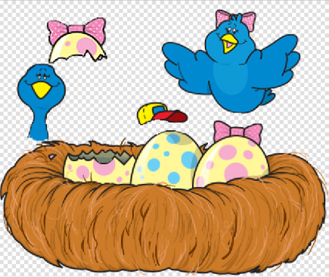
Fireworks Bird Nest Project--ANIMATION
Step 1—Download the JPG (Bird Nest) from the class website
Step 2—Open in Fireworks:
- Remove the background (magic wand; delete)
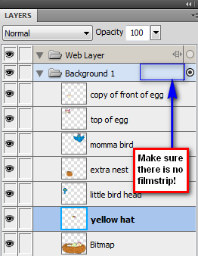
- Separate parts to layers—top of egg, momma bird, little bird head, yellow hat
- Remove momma bird’s legs and redraw any missing elements (behind the egg hat, more baby bird neck, etc.)
- Copy part of the broken egg/nest to a higher layer so that the blue bird can peek up and out of the egg (move the bird up and down and check it!!!)
- Move things around and make sure they are all going to work!!
- Touch up anything that was moved to a new layer. Watch layers carefully.
- Change the colors of the hat to be more “Eastery-y”
- Change a few spots on the egg below the hat to use some of the hat color.
- Make your blue bird a red bird. Didn’t see that coming, did ya? He he he…
- Save in Fireworks PNG format!
Step 3—Name your layers
Step 4—Make sure the folder that holds your layers DOES NOT have a filmstrip icon beside it (or you won’t be able to animate properly!!)
- If there is a filmstrip, right click it and UNCHECK Share Layers to States
Step 5—Click on your “nest” layer; on the egg with the bow, use a 2 pixel soft paintbrush and paint your initials neatly on the spots, like so
Step 6—SAVE AGAIN! Be sure it’s in Fireworks PNG format so your layers will be maintained!!
Personal note… before animating, I like to pull my Layers panel out so I can see both my Layers and States panels at the same time. Since you have to change layers to animate, I think it’s easier.
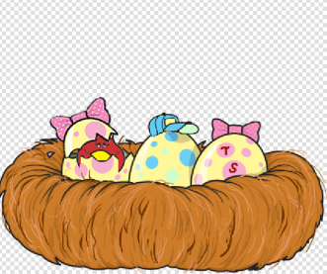
Step 7—Animate as follows: see example on my website of my finished one
- First state should be with cracked egg and bird as follows and momma bird off the top of the stage:
Step 7 (cont’d)
- Over the course of about 20 states, animate momma flying in. She should rotate a little every now and then (you can do the rotation after you’d done all the states; it’s a little easier).
- During those 20 states, modify little bird to occasionally peek up and down (at least three times).
- For states 20-30, momma just needs to hover and baby needs to pop up/down another time.
- For states 30-40, momma needs to fly over and knock the top cracked egg off and in front of the nest and the baby should sit up proudly.
- For states 40-50, baby needs to wiggle back and forth and mom needs to continue to hover.
- For states 50-60, baby needs to just straighten up and sit up; mom needs to hover in one spot
- For states 60-75, mom needs to pick up the hat with her beak (you may need to reorder layers) and put it on baby’s head. NOTE: I copied and pasted a copy of mom’s beak to put in front of the hat for this part. Also… you can hold SHIFT and click multiple pieces (like beak, momma, and hat) and be able to move them as one item) or group them (Control-G).
- For states 75-85, baby needs to wiggle around with the hat while mom hovers (group hat to bird boy).
- For states 85-110, momma needs to fly back off the screen, going BEHIND her little bird boy. (reorder layers as needed!) Bird boy should move a little bit from time to time.
- For states 110-115, bird boy should move a little bit.
- The final state should be around 115 or 120. Set the duration for that frame to be 100 (1 seconds).
- Save!
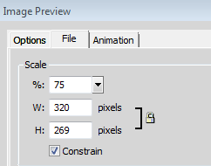
Step 8—Export the animation
- Export as an animated GIF image using the wizard. Be sure the background remains transparent.
- Set scale to 75% on export
- Save to the ANIMATE folder in your projects folder as:
finishedbird.gif
